User Guide

Shipping Raw Steel Primary Manufactures and Steel parts (Final Manufactures) to LEGO in Mexico

Table of Contents

1. User Guide Coverage 2

1.1 Purpose 2

1.2 Scope 2

2. Terms and Abbreviations 3

3. Importing Steel Parts – Context 3

3.1 Information required for customs clearance (check list). 3

3.2 Documents required to obtain the AAIPS. 4

4. Tips & Tricks 5

Appendix 6

A. MTC/MTR 6

B. Complimentary Declaration 7

C. Quality Certificate 8

# User Guide Coverage

## Purpose

The purpose of this user guide is to clarify the information and documents needed for customs clearance when shipping raw steel primary manufactures and steel parts (final manufactures) to LEGO in Mexico.

## Scope

The scope of this user guide is limited to raw steel primary manufactures and steel parts (final manufactures) shipped to LEGO in Mexico, as defined below:

* Raw steel primary manufactures: Commodities contained under Headings 7206 to 7216, 7218 to 7228 and 7304 of the HS, such as:

|  |
| --- |
| * Semifinished products |
| * Flat-rolled products |
| * Bars and rods |
| * Angles, shapes and sections |
| * Steel in ingots or other primary forms; semi-finished products of steel |
| * Tubes, pipes and hollow profiles, seamless |

* Parts made of steel (final manufactures): Commodities contained under Headings 7202, 7217, 7229, 7301, 7302, 7305 to 7308, 7312, 7314 and 7315 of the HS, such as:

|  |
| --- |
| * Ferroalloys |
| * Tubes, pipes and hollow profiles |
| * Tube or pipe fittings |
| * Structures (excluding prefabricated buildings) and parts of structures (for example, bridges and bridge sections, lock gates, towers, lattice masts, roofs, roofing frameworks, doors and windows and their frames and thresholds for doors, shutters, balustrades, pillars and columns) of iron or steel; plates,   rods, angles, shapes, sections, tubes and the like, prepared for use in structures |
| * Wire |
| * Cloth, grill, netting and fencing, of iron or steel wire |
| * Chain and parts thereof |
| * Sheet piling |
| * Railway or tramway track construction material |

This user guide applies for shipments to LEGO Group entities in Mexico.

# Terms and Abbreviations

**HS Code:** Harmonized Code, a multipurpose international product nomenclature developed by the World Customs Organization (WCO), used to classify foreign trade goods for customs purposes.

([World Customs Organization (wcoomd.org)](https://www.wcoomd.org/en/topics/nomenclature/instrument-and-tools/hs-nomenclature-2022-edition/hs-nomenclature-2022-edition.aspx)

**AAIPS:** Notice of Import for Steel products (AAIPS in Spanish language), regulated by the Mexican Ministry of Economy.

**DOF:** Official Newsletter of Mexican Government.

**Mill Test Certificate (MTC) or Mill Test Report (MTR):** The document issued by the Mill, which certifies the company that produced the steel processed in the Mill itself. It’s a document required to obtain the AAIPS from the Mexican authority, for customs clearance.

**Quality Certificate (QC):** The document that credits the manufacturer that transformed the steel, from its primary or intermediate form, for the production of the commodity to be imported, prepared by the manufacturer itself. It’s a document required to obtain the AAIPS from the Mexican authority, for customs clearance.

To see some examples of MTC/MTR/QC, please see Appendix A.

# Importing Steel Parts – Context

According to the Mexican regulation “*Acuerdo que modifica al diverso por el que la Secretaría de Economía emite reglas y criterios de carácter general en materia de Comercio Exterior*” (As reference purpose only, since is a Mexican Law and cannot be translate it without an approved Jury ) published on December 15th 2013 in the DOF, some HS Codes have a mandatory requirement to present the AAIPS in the Mexican Ministry of Economy prior to the importation of the merchandise.

This regulation affects us directly, due to its last modification in april 15th of 2024 ([DOF - Diario Oficial de la Federación](https://www.dof.gob.mx/nota_detalle.php?codigo=5723261&fecha=15/04/2024)) when some other HS Codes were included. These added HS Codes refer to some of the most common presentations of steel products and parts made of steel, as defined in the Terms and Abbreviations paragraph, imported by the LEGO Group.

The present User Guide has two sections:

* Information required for customs clearance (check list)
* Documents for the AAIPS.

## Information required for customs clearance (check list).

The following is the information and documents that the LEGO México Import/Export team require to know/have to obtain the AAIPS.:

1. Detailed description of the goods. (Example: Unalloyed galvanized steel plate coated by immersion in cold).
2. Description of the product to help identify it. (Example: steel plate, sheet, bar, profile, pipe, chain, slab, cable, etc.
3. Technical, Physical, Chemical, Metallurgical Specifications.
4. Steel Composition. Only accepted one of the following descriptions: carbon steel, alloyed, stainless steel, unalloyed, micro alloyed, hot or cold rolled.
5. Type of coating used. (Example: metal or non-metal, galvanized, zinc or nickel plated, etc.)
6. Type of finishing or complimentary work applied,such as perforated, scraped, notched, buttoned, grooved, relieved, bevelled, etc.
7. Code of product identification according to international standards.(Example: ASTM, ASME, API, SAE, etc.)
8. Transcription of chemical composition of the product.
9. Final presentation of the product. (Example: rolls, sheets, pieces, ingots, etc.).
10. Accessories included with the product, such as tees, elbows, supports, hooks, union rails, flanges, etc.
11. Dimensions, weight (mandatorily expressed in kilograms)
12. Value of the product.
13. MTC/MTR/QC number and date
14. Contact Information of the producer (name, address, email, telephone, etc.).
15. Country of origin of the steel (country where the steel was produced, smelted or cast), in the case of the Mill Certificate, or country of origin of the goods to be imported, in the case of the Quality Certificate.
16. Exporter location country (where the product is coming from).
17. Heat number (only in case of MTC/MTR).

* The MTC/MTR or the QC document must contain itself, at least, the information mentioned in numbers 1 to 3, 8,11, 13 to 15 and 17, plus the hand stamped signature, seal or QR code of the Mill or manufacturer representative.

## Documents required to obtain the AAIPS.

In order to obtain the AAIPS from the Mexican government, for the customs clearance of the merchandise, the following documents are mandatorily required:

* MTC/MTR/QC (legible copy), declaring the mandatory info and requirements expressed above.
* A complimentary declaration from the producer/manufacturer (see clarification below)
* Certificate of Origin of the goods

* The complimentary declaration from the producer/manufacturer must include any mandatory information not included in the MTC/MTR/QC, plus all the other information from the checklist. The declaration must be made on a company’s letterheaded letter, and have the producer’s/manufacturer’s company logo, date and hand stamped signature.

**Note: You can’t ship until you receive the approval from our import department, which will happen once the Mexican Ministry of Economy issues the AAIPS; therefore, it’s very important that we have all the documents and information in advance, so as not to delay the departure of the shipment.** **If your shipment doesn’t have preview approvement from us, then it takes the risk of being returned or abandoned and would be charge it to the supplier account.**

**The information requested above is the information that the Mexican authority requires from us in order to obtain the permit. Once the information has been sent to the authority, it takes approximately 5 business days to receive a response. The response can be in our favour (accepted) or not (rejected). If it is rejected, the process starts again from the beginning.**

# Tips & Tricks

* For Raw steel primary manufactures, the MTC/MTR certificate is required.
* For Parts made of steel (final manufactures), the quality certificate is required.
* Find in Appendix A examples of MTC/MTR, in Appendix B, an example of a Complimentary Declaration and in Appendix C an example of a Quality Certificate (the examples are from different shipments).

Appendix

1. MTC/MTR

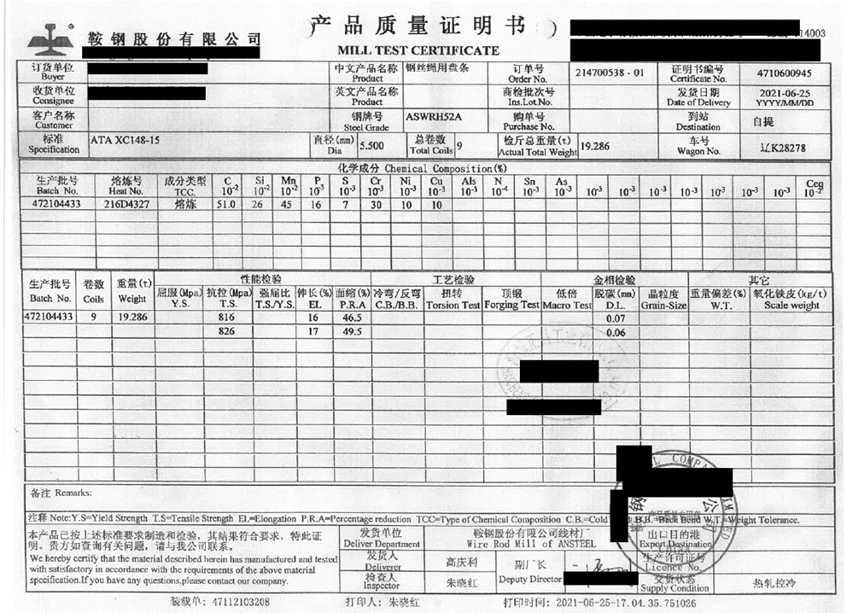

1. Complimentary Declaration

1. Quality Certificate

