Quick Guide
Guideline for shipping Dangerous goodsReview History

Version | Status | Rev. date | Description | Changed by
1.0 | Draft | 2015-06-10 | Creation | Mxjaisan
1.2 | Update | 2016-02-18 | Update | Mxdiaram
1.3 | Update | 2016-07-14 | Update | Mxcecmon
1.4 | Update | 2017-03-30 | Update | Mxmonagu
1.5 | Update | 2020-03-25 | Update | Mxjhoper

Content description
The guideline purpose is to provide a quick explanation for our vendors, to make a correct boxing and packing when shipping dangerous goods.
Definition: Dangerous goods or Hazardous Materials are substances or articles that present a risk to health, safety or that may cause damage to the environment, property or people. They need special handling or special signs.
This guideline applies to: LEGO Operaciones de Mexico, S.A. de C.V., LEGO Real Estate, S.A. de C.V.

Abbreviations
MSDS: Material Safety Data Sheets
DOT: Department of Transportation

Process
- The first step when preparing a shipment of dangerous goods is to review or know the handling that is needed that is contained on the MSDS of the material. The supplier must fill out the shipper´s declaration for dangerous goods form:
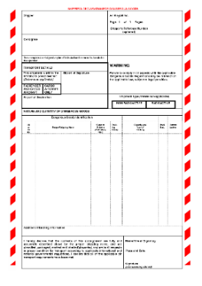
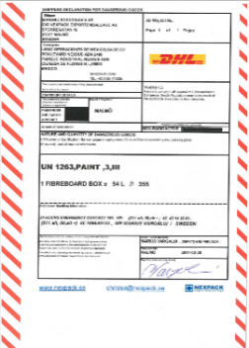
- Place D.O.T clearly visible labels on the box with general information, part number, tracking number and any other identification.
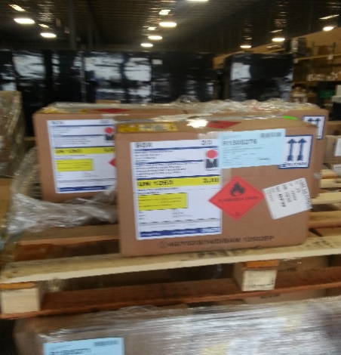
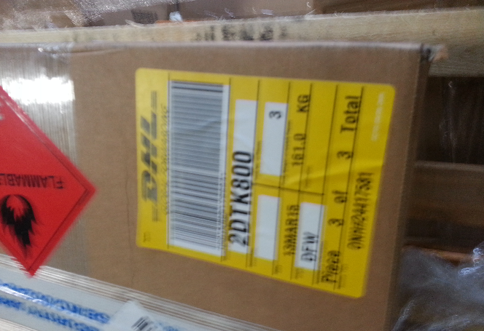

- In these examples of a correct Label, we can easily identify the following:
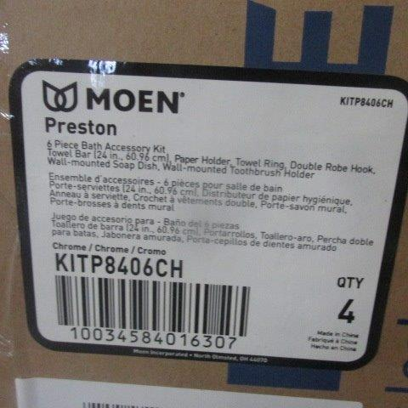
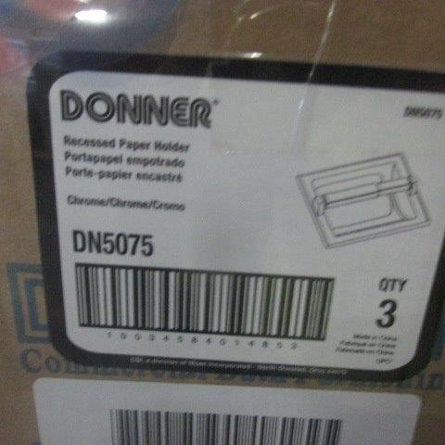
- The Part Number is clear
- The Quantity and Unit of Measure match the ones on the invoice, this is very important for auditing
- A picture/example of the item on the 1st image
- Clear Description of the Item, on the second label a more elaborate description
- Its packages with shrink wrap, but it is still visible

- Please notice that the plastic film that covers the box should be clear so it can facilitate the view for the customs authorities. (See examples below)
Correct packaging    The plastic film is clear so the information is easy to see.  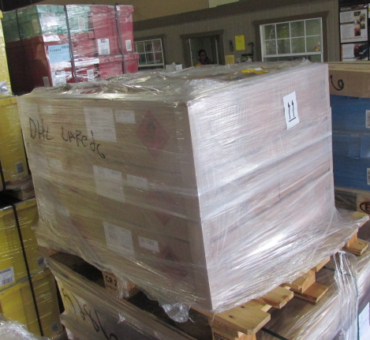 | Incorrect Packaging    This is not the way to put the plastic film as it can be seen the information on the box is not clear.  